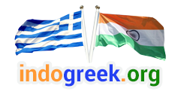
Greek Indian Cultural and Welfare Association
16, Filellion Str.- 185 36 Piraeus, Greece
E-mail: info@indogreek.org Ph- + 30 210 41 82 571, 210 41 82 571 Fax- +30 210 45 20 283

MEMBERSHIP FORM

PLEASE FILL IN THE INFORMATION BELOW.
PROMPTLY MAIL OR GIVE TO ANY OFFICE-BEARERS WITH YOUR MEMBERSHIP.

NAME: ________________________________________________________________

SPOUSE’S NAME: ____________________________________________________

CHILDREN’S NAMES: ____________________________________________________

ADDRESS: _____________________________________________________________

CITY: ______________________ STATE: _______________ ZIP: ________________

PHONE NO: HOME ______________________

E-MAIL: ______________________________________________________________

Thank you.

Date: ________________________

